[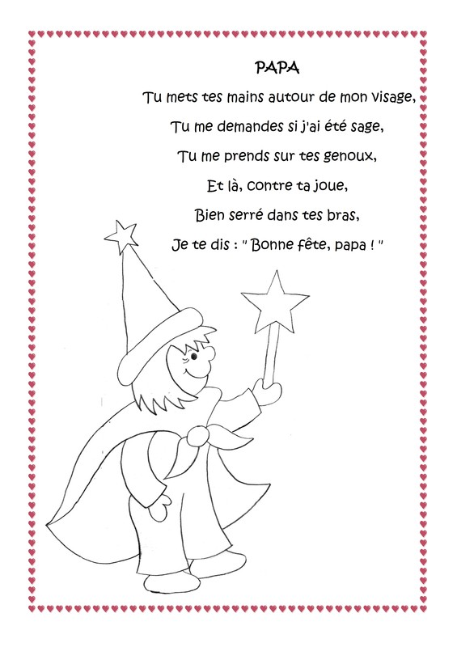](http://nounoulolo88.centerblog.net/rub-comptines-fete-des-papas-.html)